Stage 3 Physics: Motion and Forces in Electric and Magnetic Fields

UNIT TEST

Name: Suggested Answers (40 marks)
- When drawing field lines around point charges, they are drawn such that the lines are closer together near the point charge but further apart as you move away.

  - Explain what this tells us about the fields around point charges. (1 mark)

The closer you are to the point charge, the stronger the field so the lines are closer together.

In parallel plates however, the lines are drawn parallel and the same distance apart.
b. Why is this different to point charges? (1 mark)

The field between parallel plates is uniform throughout so the lines show the that there is no change in the strength and direction of the field.

- Draw the electric field lines for the following two situations. (4 marks)

  - Two positively charged point charges. b. A positive point charge above a negatively
charged plate.
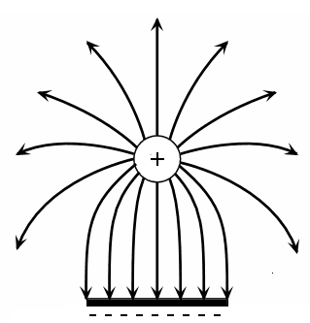
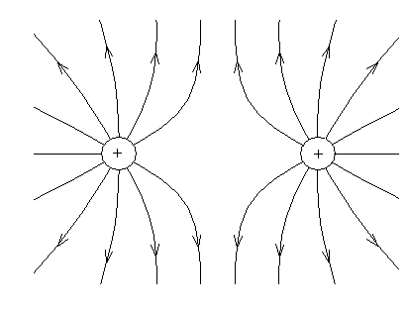

- A pith ball (small foam ball) has been given a charge of -8.45 x 10⁻² μC and is placed within an electric field. The pith ball experiences a force of 4.25 x 10⁻⁴ N north.
  - Calculate the magnitude of the field at that point. (2 marks)

E = 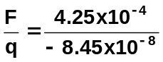
E = -5.03 x 10³ N C⁻¹

  - What is the direction of the force? Explain your answer. (2 marks)

The direction will be South.

Field direction is the way a positively charged particle would move.
Negative charges move in the opposite direction to the field so as the field is
north, the charge will move south.

- In an experiment, two parallel plates are set up in a vacuum. The plates are 2.50 cm apart and connected to opposite terminals of a 240 V power supply
  - Determine the magnitude of the electric field between the plates. (2 marks)

E = 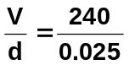
E = 9600
E = 9.60 x 10³ V m⁻¹

  - Calculate the force the electric field exerts on an electron within the field. (2 marks)

F = Eq
= 9600 x 1.6 x 10⁻¹⁹
F = 1.54 x 10⁻¹⁵ N

  - Calculate the lost in potential energy for an electron as it leaves the negative plate and hits the positive plate. (2 marks)

Work = energy = F x s OR Work = energy = Vq
= 1.54 x 10⁻¹⁵ x 0.025 = 240 x 1.6 x 10⁻¹⁹
= 3.85 x 10⁻¹⁷ J = 3.85 x 10⁻¹⁷ J

  - Calculate the maximum speed of the electron. (2 marks)

All the potential energy is converted to kinetic energy

E_{k} = ½ mv²
3.85 x 10⁻¹⁷ = 0.5 x 9.11 x 10⁻³¹ x v²
v = 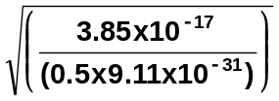
v = 9.19 x 10⁶ m s⁻¹

  - If the plates were moved closer, how would it affect:

    - the electric field strength between the plates? Explain. (2 marks)

No effect.
Power supply not changed so charge on plates not altered, so field lines are
the same.

    - the potential difference? Explain. (2 marks)

Must decrease.
V = Ed, field is constant so if ‘d’ decreases, V must decrease.

- A charged particle of mass 3.80 x 10⁻⁶ g is suspended between two plates as shown. The plates are 5.45 mm apart.

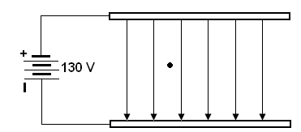

- Determine the strength of the electric field between them. (2 marks)

E = 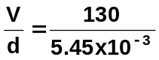 = 23853
E = 2.39 x 10⁴ V m⁻¹

- Calculate the charge on the particle. (3 marks)

since suspended, mg = Eq
3.80 x 10⁻⁹ x 9.8 = 2.39 x 10⁴ x q
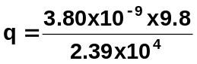
q = 1.56 x 10⁻¹² C

- The charge is due to a number of excess electrons on the particle. Calculate the number of excess electrons. (1 mark)

excess electrons = 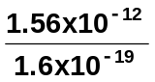
= 9.76 x 10⁶ electrons

- Calculate the force on an electron which is moving horizontally with a constant velocity of 8.25 x 10⁷ m s⁻¹ south when it enters a uniform magnetic field of 5.5 x 10⁻³ T east. (2 marks)

F = Bvq
= 5.5 x 10⁻³ x 8.25 x 10⁷ x 1.6 x 10⁻¹⁹
F = 7.26 x 10⁻¹⁴ N

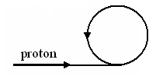
- A proton experiences a force of 2.11 x 10⁻¹⁴ N when it enters a magnetic field as shown in the diagram. The velocity of the proton is 1.50 x 10⁶ ms⁻¹.

- Describe the direction of the magnetic field. (1 mark)
into the page
- Calculate the strength of the magnetic field that is acting on the proton. (2 marks)

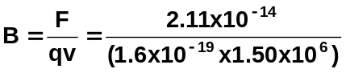
B = 8.80 x 10⁻² T

- What is the diameter of the path followed by the proton? (3 marks)

F_{e} = F_{c}
Bvq = 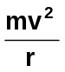
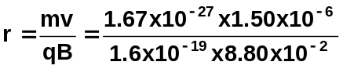
r = 0.1779 m

diameter = 2 x r
= 2 x 0.1779
diameter = 0.356 m

- Calculate the frequency of the path of the proton. (2 marks)

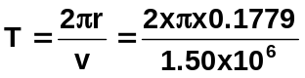
T = 7.45 x 10⁻⁷ s

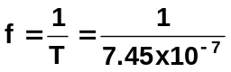

f = 1.23 x 10⁶ Hz

- The diagram below shows a uniform magnetic field with three particles A, B and C having masses and charges as shown in the table below. They each enter the magnetic field with the same velocity, v. Complete the diagram to show the paths of particles A, B and C.
(3 marks)

Particle | Relative charge | Relative mass
A | 1 + | m
B | 2 + | 2m
C | 1 - | m

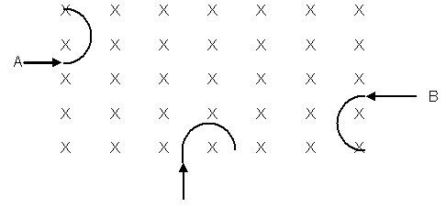
For all particles A and C same radius but different direction
F_{e} = F_{c} B: r_{B} = 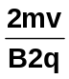 2’s cancel so same r as A and C
r = 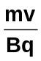
Students may have different diagrams to above but
the key idea is that the radius for each is the same

